TABLE OF CONTENTS

Website Goal……………………………………………….. Page 2
Homepage………………………………………………….. Page 3
About Page…………………………………………………. Page 5
Useful Information Page…………………………………… Page 7
Contact Us Page……………………………………………. Page 9
Site Map……………………………………………………. Page 11
List of Sources……………………………………………... Page 12
WEBSITE GOAL

My website is built to target the audience that are eager in exploring new locations, new cuisine or simply to fulfil the knowledge of the history.

The website gives you brief guidelines in what to explore together with externally accessible links to get more detailed information about your possible upcoming trip to Daugavpils, Latvia.

Website is built with Mobile First design view together with fully responsive pages and added accessibility features.

HOMEPAGE

Homepage contains the following: -
- Header Bar with Navigation
- Main Body with external links
- Footer Bar

Header Bar
Long bar across the top of the page to have a small ‘Flag of Latvia’ image to the left, following by the Title ‘Welcome to Daugavpils’. Title is also a link back to Homepage.
Four horizontally aligned and centred Navigation Links ‘Home, About, Useful Information, Contact Us’ bring you to their separate webpages once clicked. Links to have an effect, once hovered over of transforming to upper case and turning green in colour.
Header Bar to be from side to side with inside padding.
For the range of smaller screens, small logo will disappear and Navigation will turn vertically, right side aligned.
Main Body
Small all-around margin to give breathing spaces to the edges.
Horizontal Image Slider Bar side to side with three separate images with a hold of 10 seconds for the first image. Images are ‘Daugavpils Fortress’, ‘Nature’ and ‘Daugava River’.
Next to follow three Bootstrap same height containers evenly aligned that contain a Heading, Brief Description and an external Link for more detailed information on each topic.
Containers to stretch vertically for smaller screens. Links to have an effect, once hovered over of transforming to upper case and turning green in colour.
At the bottom of the Homepage is an image of ‘Map of Latvia’ with a Header ‘Map of Latvia’. In image is surrounded by same colour border as the Header and Footer of the website. The image to disappear for smaller device screens.
Footer
Long bar across the bottom of the page with Copyright text ‘© 2026 Visit Daugavpils by Natalija Tiron. UCD WebDesign Module I.’
ABOUT PAGE

Homepage contains the following: -
- Header Bar with Navigation
- Main Body with external links
- Footer Bar

Header Bar
Long bar across the top of the page to have a small ‘Flag of Latvia’ image to the left, following by the Title ‘Welcome to Daugavpils’. Title is also a link back to Homepage.
Four horizontally aligned and centred Navigation Links ‘Home, About, Useful Information, Contact Us’ bring you to their separate webpages once clicked. Links to have an effect, once hovered over of transforming to upper case and turning green in colour.
Header Bar to be from side to side with inside padding.
For the range of smaller screens, small logo will disappear and Navigation will turn vertically, right side aligned.
Main Body
Two parts containing image and texts.
Main Section to sit in a border of the same colour as webpage Header and Footer with page title ‘About Daugavpils’, an image of a ‘Church Hill’ area in Daugavpils and a few short paragraphs about Daugavpils.
Section underneath is an ‘aside’ container containing bullet points of ‘Interesting Facts about Latvia’, with same name Title. ‘Aside’ container to change background and border colour to purple on hover over.
‘Aside’ container to disappear for smaller device screens.
Footer
Long bar across the bottom of the page with Copyright text ‘© 2026 Visit Daugavpils by Natalija Tiron. UCD WebDesign Module I.’
USEFUL INFORMATION PAGE

Homepage contains the following: -
- Header Bar with Navigation
- Main Body with external links
- Footer Bar

Header Bar
Long bar across the top of the page to have a small ‘Flag of Latvia’ image to the left, following by the Title ‘Welcome to Daugavpils’. Title is also a link back to Homepage.
Four horizontally aligned and centred Navigation Links ‘Home, About, Useful Information, Contact Us’ bring you to their separate webpages once clicked. Links to have an effect, once hovered over of transforming to upper case and turning green in colour.
Header Bar to be from side to side with inside padding.
For the range of smaller screens, small logo will disappear and Navigation will turn vertically, right side aligned.
Main Body
Two parts containing texts and a YouTube video.
All to sit in a border of the same colour as webpage Header and Footer, with page title ‘Useful Information’. Two Forms evenly spaced out horizontally, containing ‘Average Yearly Temperatures’ and ‘Nearby Airports’ that will align vertically for smaller screens. Forms to change background and border colour to purple on hover over.
A live YouTube video underneath will disappear for smaller screens.
Footer
Long bar across the bottom of the page with Copyright text ‘© 2026 Visit Daugavpils by Natalija Tiron. UCD WebDesign Module I.’
CONTACT US PAGE

Homepage contains the following: -
- Header Bar with Navigation
- Main Body with external links
- Footer Bar

Header Bar
Long bar across the top of the page to have a small ‘Flag of Latvia’ image to the left, following by the Title ‘Welcome to Daugavpils’. Title is also a link back to Homepage.
Four horizontally aligned and centred Navigation Links ‘Home, About, Useful Information, Contact Us’ bring you to their separate webpages once clicked. Links to have an effect, once hovered over of transforming to upper case and turning green in colour.
Header Bar to be from side to side with inside padding.
For the range of smaller screens, small logo will disappear and Navigation will turn vertically, right side aligned.
Main Body
Contains a fully accessible and responsive ‘Contact Form’ with fields descriptions and simulated ‘Send’ button on the bottom that changes background colour to green and text into uppercase.
Fields are as follows: -
- Full Name
- Email
- Subject
- Message

Footer
Long bar across the bottom of the page with Copyright text ‘© 2026 Visit Daugavpils by Natalija Tiron. UCD WebDesign Module I.’
SITE MAP

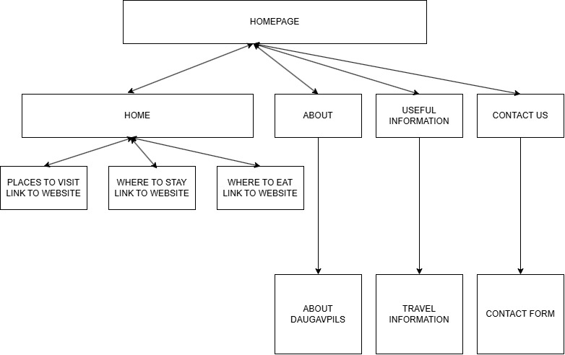

LIST OF SOURCES

Homepage
- Homepage – Image Slider - https://www.youtube.com/watch?v=A1afpqeBHBc by
Web Tech Knowledge
- Bootstrap Containers Design taken from Unit 9 Video
- Bootstrap containers Height Adjustment fix - https://www.youtube.com/watch?v=GC4YAUVDqiI
  - Containers Texts - https://www.latvia.travel/en/meet-daugavpils - information changed into brief descriptions
  - Map of Latvia Image - https://www.worldatlas.com/maps/latvia - pixels adjusted to suit my page

About Page
  - Church Hill Image - https://www.latvia.travel/en/pils%C4%93ta/daugavpils
  - Text - https://www.latvia.travel/en/pils%C4%93ta/daugavpils
  - Interesting Facts about Latvia - https://www.latvia.travel/en/interesting-facts-about-latvia

Useful Information Page
- Average Yearly Temperatures - https://www.climatestotravel.com/climate/latvia/daugavpils
- Nearby Airports – Google Search
- Useful Information Page – YouTube video - https://www.youtube.com/watch?v=Y8DHlo7yIJ0

Contact Us Page
- Contact Form taken from Unit 13

